**Project Structure**

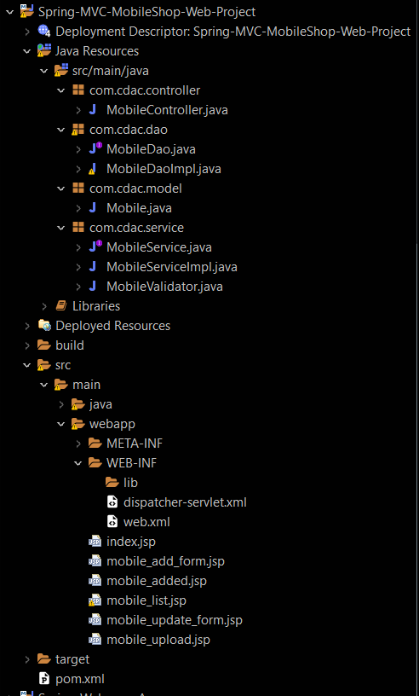

**Pom.xml**

<project xmlns="http://maven.apache.org/POM/4.0.0" xmlns:xsi="http://www.w3.org/2001/XMLSchema-instance" xsi:schemaLocation="http://maven.apache.org/POM/4.0.0 https://maven.apache.org/xsd/maven-4.0.0.xsd">

<modelVersion>4.0.0</modelVersion>

<groupId>com.cdac</groupId>

<artifactId>Spring-MVC-MobileShop-Web-Project</artifactId>

<version>0.0.1-SNAPSHOT</version>

<packaging>war</packaging>

<name>Spring-MVC-MobileShop-Web-Project</name>

<description>Spring Project</description>

<build>

<plugins>

<plugin>

<artifactId>maven-compiler-plugin</artifactId>

<version>3.8.1</version>

<configuration>

<release>17</release>

</configuration>

</plugin>

<plugin>

<artifactId>maven-war-plugin</artifactId>

<version>3.2.3</version>

</plugin>

</plugins>

</build>

<properties>

<spring.version>4.3.20.RELEASE</spring.version>

<aspectj.version>1.8.13</aspectj.version>

<mysql.connector.version>8.0.13</mysql.connector.version>

<hibernate.version>4.3.0.Final</hibernate.version>

</properties>

<dependencies>

<dependency>

<groupId>org.springframework</groupId>

<artifactId>spring-core</artifactId>

<version>${spring.version}</version>

</dependency>

<dependency>

<groupId>org.springframework</groupId>

<artifactId>spring-beans</artifactId>

<version>${spring.version}</version>

</dependency>

<dependency>

<groupId>org.springframework</groupId>

<artifactId>spring-context</artifactId>

<version>${spring.version}</version>

</dependency>

<dependency>

<groupId>org.springframework</groupId>

<artifactId>spring-context-support</artifactId>

<version>${spring.version}</version>

</dependency>

<dependency>

<groupId>org.springframework</groupId>

<artifactId>spring-jdbc</artifactId>

<version>${spring.version}</version>

</dependency>

<dependency>

<groupId>org.springframework</groupId>

<artifactId>spring-orm</artifactId>

<version>${spring.version}</version>

</dependency>

<dependency>

<groupId>org.springframework</groupId>

<artifactId>spring-web</artifactId>

<version>${spring.version}</version>

</dependency>

<dependency>

<groupId>org.springframework</groupId>

<artifactId>spring-webmvc</artifactId>

<version>${spring.version}</version>

</dependency>

<dependency>

<groupId>org.springframework</groupId>

<artifactId>spring-aop</artifactId>

<version>${spring.version}</version>

</dependency>

<dependency>

<groupId>org.aspectj</groupId>

<artifactId>aspectjrt</artifactId>

<version>${aspectj.version}</version>

</dependency>

<dependency>

<groupId>org.aspectj</groupId>

<artifactId>aspectjweaver</artifactId>

<version>${aspectj.version}</version>

</dependency>

<dependency>

<groupId>mysql</groupId>

<artifactId>mysql-connector-java</artifactId>

<version>${mysql.connector.version}</version>

</dependency>

<dependency>

<groupId>org.hibernate</groupId>

<artifactId>hibernate-core</artifactId>

<version>${hibernate.version}</version>

</dependency>

<dependency>

<groupId>org.hibernate</groupId>

<artifactId>hibernate-entitymanager</artifactId>

<version>${hibernate.version}</version>

</dependency>

<dependency>

<groupId>org.hibernate</groupId>

<artifactId>hibernate-ehcache</artifactId>

<version>${hibernate.version}</version>

</dependency>

<dependency>

<groupId>commons-fileupload</groupId>

<artifactId>commons-fileupload</artifactId>

<version>1.4</version>

</dependency>

<dependency>

<groupId>org.apache.tomcat</groupId>

<artifactId>tomcat-annotations-api</artifactId>

<version>9.0.62</version>

</dependency>

<dependency>

<groupId>org.apache.tomcat</groupId>

<artifactId>tomcat-catalina-ant</artifactId>

<version>9.0.62</version>

</dependency>

<dependency>

<groupId>org.apache.tomcat</groupId>

<artifactId>tomcat-catalina-ha</artifactId>

<version>9.0.62</version>

</dependency>

<dependency>

<groupId>org.apache.tomcat</groupId>

<artifactId>tomcat-ssi</artifactId>

<version>9.0.62</version>

</dependency>

<dependency>

<groupId>org.apache.tomcat</groupId>

<artifactId>tomcat-storeconfig</artifactId>

<version>9.0.62</version>

</dependency>

<dependency>

<groupId>org.apache.tomcat</groupId>

<artifactId>tomcat-tribes</artifactId>

<version>9.0.62</version>

</dependency>

<dependency>

<groupId>org.apache.tomcat</groupId>

<artifactId>tomcat-catalina</artifactId>

<version>9.0.62</version>

</dependency>

<dependency>

<groupId>org.eclipse.jdt</groupId>

<artifactId>ecj</artifactId>

<version>3.26.0</version>

</dependency>

<dependency>

<groupId>org.apache.tomcat</groupId>

<artifactId>tomcat-el-api</artifactId>

<version>9.0.62</version>

</dependency>

<dependency>

<groupId>org.apache.tomcat</groupId>

<artifactId>tomcat-jasper-el</artifactId>

<version>9.0.62</version>

</dependency>

<dependency>

<groupId>org.apache.tomcat</groupId>

<artifactId>tomcat-jasper</artifactId>

<version>9.0.62</version>

</dependency>

<dependency>

<groupId>org.apache.tomcat</groupId>

<artifactId>tomcat-jaspic-api</artifactId>

<version>9.0.62</version>

</dependency>

<dependency>

<groupId>org.apache.tomcat</groupId>

<artifactId>tomcat-jsp-api</artifactId>

<version>9.0.62</version>

</dependency>

<dependency>

<groupId>org.apache.tomcat</groupId>

<artifactId>tomcat-servlet-api</artifactId>

<version>9.0.62</version>

</dependency>

<dependency>

<groupId>org.apache.tomcat</groupId>

<artifactId>tomcat-api</artifactId>

<version>9.0.62</version>

</dependency>

<dependency>

<groupId>org.apache.tomcat</groupId>

<artifactId>tomcat-coyote</artifactId>

<version>9.0.62</version>

</dependency>

<dependency>

<groupId>org.apache.tomcat</groupId>

<artifactId>tomcat-dbcp</artifactId>

<version>9.0.62</version>

</dependency>

<dependency>

<groupId>org.apache.tomcat</groupId>

<artifactId>tomcat-i18n-cs</artifactId>

<version>9.0.62</version>

</dependency>

<dependency>

<groupId>org.apache.tomcat</groupId>

<artifactId>tomcat-i18n-de</artifactId>

<version>9.0.62</version>

</dependency>

<dependency>

<groupId>org.apache.tomcat</groupId>

<artifactId>tomcat-i18n-es</artifactId>

<version>9.0.62</version>

</dependency>

<dependency>

<groupId>org.apache.tomcat</groupId>

<artifactId>tomcat-i18n-fr</artifactId>

<version>9.0.62</version>

</dependency>

<dependency>

<groupId>org.apache.tomcat</groupId>

<artifactId>tomcat-i18n-ja</artifactId>

<version>9.0.62</version>

</dependency>

<dependency>

<groupId>org.apache.tomcat</groupId>

<artifactId>tomcat-i18n-ko</artifactId>

<version>9.0.62</version>

</dependency>

<dependency>

<groupId>org.apache.tomcat</groupId>

<artifactId>tomcat-i18n-pt-BR</artifactId>

<version>9.0.62</version>

</dependency>

<dependency>

<groupId>org.apache.tomcat</groupId>

<artifactId>tomcat-i18n-ru</artifactId>

<version>9.0.62</version>

</dependency>

<dependency>

<groupId>org.apache.tomcat</groupId>

<artifactId>tomcat-i18n-zh-CN</artifactId>

<version>9.0.62</version>

</dependency>

<dependency>

<groupId>org.apache.tomcat</groupId>

<artifactId>tomcat-jdbc</artifactId>

<version>9.0.62</version>

</dependency>

<dependency>

<groupId>org.apache.tomcat</groupId>

<artifactId>tomcat-jni</artifactId>

<version>9.0.62</version>

</dependency>

<dependency>

<groupId>org.apache.tomcat</groupId>

<artifactId>tomcat-util-scan</artifactId>

<version>9.0.62</version>

</dependency>

<dependency>

<groupId>org.apache.tomcat</groupId>

<artifactId>tomcat-util</artifactId>

<version>9.0.62</version>

</dependency>

<dependency>

<groupId>org.apache.tomcat</groupId>

<artifactId>tomcat-websocket</artifactId>

<version>9.0.62</version>

</dependency>

<dependency>

<groupId>org.apache.tomcat</groupId>

<artifactId>tomcat-websocket-api</artifactId>

<version>9.0.62</version>

</dependency>

</dependencies>

</project>

**Web.xml**

<?xml version="1.0" encoding="UTF-8"?>

<web-app xmlns:xsi="http://www.w3.org/2001/XMLSchema-instance"

xmlns="http://xmlns.jcp.org/xml/ns/javaee"

xsi:schemaLocation="http://xmlns.jcp.org/xml/ns/javaee http://xmlns.jcp.org/xml/ns/javaee/web-app_4_0.xsd"

id="WebApp_ID" version="4.0">

<display-name>Spring-MVC-MobileShop-Web-Project</display-name>

<welcome-file-list>

<welcome-file>index.html</welcome-file>

<welcome-file>index.jsp</welcome-file>

<welcome-file>index.htm</welcome-file>

<welcome-file>default.html</welcome-file>

<welcome-file>default.jsp</welcome-file>

<welcome-file>default.htm</welcome-file>

</welcome-file-list>

<servlet>

<servlet-name>dispatcher</servlet-name>

<servlet-class>org.springframework.web.servlet.DispatcherServlet</servlet-class>

</servlet>

<servlet-mapping>

<servlet-name>dispatcher</servlet-name>

<url-pattern>*.htm</url-pattern>

</servlet-mapping>

</web-app>

**Dispatcher-servlet.xml**

<?xml version="1.0" encoding="UTF-8"?>

<beans xmlns="http://www.springframework.org/schema/beans"

xmlns:xsi="http://www.w3.org/2001/XMLSchema-instance"

xmlns:aop="http://www.springframework.org/schema/aop"

xmlns:context="http://www.springframework.org/schema/context"

xmlns:jdbc="http://www.springframework.org/schema/jdbc"

xmlns:mvc="http://www.springframework.org/schema/mvc"

xmlns:p="http://www.springframework.org/schema/p"

xsi:schemaLocation="http://www.springframework.org/schema/beans http://www.springframework.org/schema/beans/spring-beans-4.3.xsd

http://www.springframework.org/schema/aop http://www.springframework.org/schema/aop/spring-aop-4.3.xsd

http://www.springframework.org/schema/context http://www.springframework.org/schema/context/spring-context-4.3.xsd

http://www.springframework.org/schema/jdbc http://www.springframework.org/schema/jdbc/spring-jdbc-4.3.xsd

http://www.springframework.org/schema/mvc http://www.springframework.org/schema/mvc/spring-mvc-4.3.xsd">

<context:component-scan base-package="com.cdac"></context:component-scan>

<bean id="viewResolver" class="org.springframework.web.servlet.view.InternalResourceViewResolver" >

<property name="prefix" value="/" ></property>

<property name="suffix" value=".jsp" ></property>

</bean>

<bean id="multipartResolver" class="org.springframework.web.multipart.commons.CommonsMultipartResolver" ></bean>

<bean id="dataSource" class="org.springframework.jdbc.datasource.DriverManagerDataSource" >

<property name="driverClassName" value="com.mysql.cj.jdbc.Driver" ></property>

<property name="url" value="jdbc:mysql://localhost:3306/pune?allowPublicKeyRetrieval=true" ></property>

<property name="username" value="root" ></property>

<property name="password" value="cdac" ></property>

</bean>

<bean id="sessionFactory" class="org.springframework.orm.hibernate4.LocalSessionFactoryBean" autowire="byType" >

<property name="hibernateProperties">

<props>

<prop key="hibernate.dialect">org.hibernate.dialect.MySQLDialect</prop>

<prop key="hibernate.show_sql">true</prop>

<prop key="hibernate.hbm2ddl.auto">update</prop>

</props>

</property>

<property name="annotatedClasses">

<list>

<value>com.cdac.model.Mobile</value>

</list>

</property>

</bean>

<bean id="hibernateTemplate" class="org.springframework.orm.hibernate4.HibernateTemplate" autowire="byType" ></bean>

</beans>

**Mobile.java**

package com.cdac.model;

import javax.persistence.Entity;

import javax.persistence.GeneratedValue;

import javax.persistence.GenerationType;

import javax.persistence.Id;

import javax.persistence.Table;

@Entity

@Table(name = "mobile_table")

public class Mobile {

@Id

@GeneratedValue(strategy = GenerationType.IDENTITY)

private int id;

private String company;

private String model;

private double price;

private String image;

public Mobile() {

}

public Mobile(int id) {

super();

this.id = id;

}

public Mobile(String company, String model, double price) {

super();

this.company = company;

this.model = model;

this.price = price;

}

public Mobile(int id, String company, String model, double price) {

super();

this.id = id;

this.company = company;

this.model = model;

this.price = price;

}

public int getId() {

return id;

}

public void setId(int id) {

this.id = id;

}

public String getCompany() {

return company;

}

public void setCompany(String company) {

this.company = company;

}

public String getModel() {

return model;

}

public void setModel(String model) {

this.model = model;

}

public double getPrice() {

return price;

}

public void setPrice(double price) {

this.price = price;

}

public String getImage() {

return image;

}

public void setImage(String image) {

this.image = image;

}

@Override

public String toString() {

return id + " " + company + " " + model + " " + price;

}

}

**MovibleDao.java**

package com.cdac.dao;

import java.util.List;

import com.cdac.model.Mobile;

public interface MobileDao {

void save(Mobile mobile);

void modify(Mobile mobile);

void deleteById(int id);

Mobile selectById(int id);

List<Mobile> selectAll();

void upload (int id, String image);

}

**MovibleDaoImpl.java**

package com.cdac.dao;

import java.util.List;

import org.hibernate.Query;

import org.hibernate.Transaction;

import org.springframework.beans.factory.annotation.Autowired;

import org.springframework.orm.hibernate4.HibernateTemplate;

import org.springframework.stereotype.Repository;

import com.cdac.model.Mobile;

@Repository

public class MobileDaoImpl implements MobileDao {

@Autowired

private HibernateTemplate hibernateTemplate;

// insert

@Override

public void save(Mobile mobile) {

hibernateTemplate.execute(session -> {

Transaction t = session.beginTransaction();

session.save(mobile);

t.commit();

session.flush();

session.close();

return null;

});

}

// update

@Override

public void modify(Mobile mobile) {

hibernateTemplate.execute(session -> {

Transaction t = session.beginTransaction();

session.update(mobile);

t.commit();

session.flush();

session.close();

return null;

});

}

// delete

@Override

public void deleteById(int id) {

hibernateTemplate.execute(session -> {

Transaction t = session.beginTransaction();

session.delete(new Mobile(id));

t.commit();

session.flush();

session.close();

return null;

});

}

@Override

public Mobile selectById(int id) {

return hibernateTemplate.execute(session -> {

Transaction t = session.beginTransaction();

Mobile mobile = (Mobile) session.get(Mobile.class, id);

t.commit();

session.flush();

session.close();

return mobile;

});

}

@Override

public List<Mobile> selectAll() {

return hibernateTemplate.execute(session -> {

Transaction t = session.beginTransaction();

Query q = session.createQuery("from Mobile");

List<Mobile> lst = q.list();

t.commit();

session.flush();

session.close();

return lst;

});

}

@Override

public void upload(int id, String image) {

hibernateTemplate.execute(session -> {

Transaction t = session.beginTransaction();

Mobile mobile = (Mobile) session.get(Mobile.class, id);

mobile.setImage(image);

t.commit();

session.flush();

session.close();

return null;

});

}

}

**MovibleService.java**

package com.cdac.service;

import java.util.List;

import com.cdac.model.Mobile;

public interface MobileService {

void insert(Mobile mobile);

void update(Mobile mobile);

void deleteById(int id);

Mobile getById(int id);

List<Mobile> getAll();

void upload(int id, String image);

}

**MovibleServiceImpl.java**

package com.cdac.service;

import java.util.List;

import org.springframework.beans.factory.annotation.Autowired;

import org.springframework.stereotype.Service;

import com.cdac.dao.MobileDao;

import com.cdac.model.Mobile;

@Service

public class MobileServiceImpl implements MobileService {

@Autowired

private MobileDao mobileDao;

@Override

public void insert(Mobile mobile) {

mobileDao.save(mobile);

}

@Override

public void update(Mobile mobile) {

mobileDao.modify(mobile);

}

@Override

public void deleteById(int id) {

mobileDao.deleteById(id);

}

@Override

public Mobile getById(int id) {

return mobileDao.selectById(id);

}

@Override

public List<Mobile> getAll() {

return mobileDao.selectAll();

}

@Override

public void upload(int id, String image) {

mobileDao.upload(id, image);

}

}

**MobileValidator.java**

package com.cdac.service;

import org.springframework.stereotype.Service;

import org.springframework.validation.Errors;

import org.springframework.validation.ValidationUtils;

import org.springframework.validation.Validator;

import com.cdac.model.Mobile;

@Service

public class MobileValidator implements Validator {

@Override

public boolean supports(Class<?> clazz) {

return clazz.equals(Mobile.class);

}

@Override

public void validate(Object target, Errors errors) {

ValidationUtils.rejectIfEmptyOrWhitespace(errors, "company", "company_err", "company required");

ValidationUtils.rejectIfEmptyOrWhitespace(errors, "model", "model_err", "model required");

Mobile mobile = (Mobile) target;

if (mobile.getPrice() <= 0) {

errors.rejectValue("price", "price_err", "price can not be 0 or less");

}

}

}

**MobileController.java**

package com.cdac.controller;

import java.nio.file.Files;

import java.nio.file.Path;

import java.nio.file.Paths;

import java.nio.file.StandardCopyOption;

import java.util.List;

import javax.servlet.ServletContext;

import javax.servlet.http.HttpServletRequest;

import org.springframework.beans.factory.annotation.Autowired;

import org.springframework.stereotype.Controller;

import org.springframework.ui.ModelMap;

import org.springframework.validation.BindingResult;

import org.springframework.web.bind.annotation.RequestMapping;

import org.springframework.web.bind.annotation.RequestMethod;

import org.springframework.web.bind.annotation.RequestParam;

import org.springframework.web.multipart.commons.CommonsMultipartFile;

import com.cdac.model.Mobile;

import com.cdac.service.MobileService;

import com.cdac.service.MobileValidator;

@Controller

public class MobileController {

@Autowired

private MobileService mobileService;

@Autowired

private MobileValidator mobileValidator;

@RequestMapping(value = { "/mobile_add_form.htm" })

public String mobileAddForm(ModelMap model) {

model.put("mobile", new Mobile());

return "mobile_add_form";

}

@RequestMapping(value = { "/mobile_added.htm" }, method = RequestMethod.POST)

public String mobileAdd(Mobile mobile, BindingResult result, ModelMap model) {

mobileValidator.validate(mobile, result);

if (result.hasErrors())

return "mobile_add_form";

mobileService.insert(mobile);

model.put("mobile", mobile);

return "mobile_added";

}

@RequestMapping(value = { "/mobile_list.htm" }, method = RequestMethod.GET)

public String mobileList(ModelMap model) {

List<Mobile> lst = mobileService.getAll();

model.put("mobiles", lst);

return "mobile_list";

}

@RequestMapping(value = { "/mobile_delete.htm" }, method = RequestMethod.GET)

public String mobileDelete(@RequestParam(name = "id") int id, ModelMap model) {

mobileService.deleteById(id);

List<Mobile> lst = mobileService.getAll();

model.put("mobiles", lst);

return "mobile_list";

}

@RequestMapping(value = { "/mobile_update_form.htm" }, method = RequestMethod.GET)

public String mobileUpdateForm(@RequestParam(name = "id") int id, ModelMap model) {

Mobile m = mobileService.getById(id);

model.put("mobile", m);

return "mobile_update_form";

}

@RequestMapping(value = { "/mobile_update.htm" }, method = RequestMethod.POST)

public String mobileUpdate(Mobile mobile, ModelMap model) {

mobileService.update(mobile);

List<Mobile> lst = mobileService.getAll();

model.put("mobiles", lst);

return "mobile_list";

}

@RequestMapping(value = { "/mobile_upload.htm" }, method = RequestMethod.POST)

public String mobileUpload(@RequestParam int id, @RequestParam CommonsMultipartFile image, ModelMap model,

HttpServletRequest request) {

try {

ServletContext sc = request.getServletContext();

String filePath = sc.getRealPath("images");

Path path = Paths.get(filePath);

if (!Files.exists(path)) {

Files.createDirectory(path);

}

String fileName = image.getOriginalFilename();

fileName = fileName.substring(fileName.lastIndexOf('.'));

fileName = id + fileName;

path = path.resolve(fileName);

Files.copy(image.getInputStream(), path, StandardCopyOption.REPLACE_EXISTING);

System.out.println(path);

mobileService.upload(id, fileName);

} catch (Exception e) {

e.printStackTrace();

}

List<Mobile> lst = mobileService.getAll();

model.put("mobiles", lst);

return "mobile_list";

}

}

**index.java**

<%@ **page** language="java" contentType="text/html; charset=UTF-8"

pageEncoding="UTF-8"%>

<!DOCTYPE html>

<html>

<head>

<meta charset="UTF-8">

<title>Welcome Page</title>

</head>

<body>

<div align="center">

<h2>Mobile Management System</h2>

<br> <a href="mobile_add_form.htm"><b>Add Mobile</b></a> <br> <br>

<a href="mobile_list.htm"><b>View Mobile List</b></a>

</div>

</body>

</html>

**mobile_add_form.jsp**

<%@ **page** language="java" contentType="text/html; charset=UTF-8"

pageEncoding="UTF-8"%>

<%@ **taglib** uri="http://www.springframework.org/tags/form" prefix="spr"%>

<!DOCTYPE html>

<html>

<head>

<meta charset="UTF-8">

<title>Mobile Add Form</title>

</head>

<body>

<div align="center">

<h2>Mobile add form</h2>

<br> <br>

<**spr:form** action="mobile_added.htm" commandName="mobile" method="post">

<div>

<label>Company :</label>

<**spr:input** path="company" />

<span style="color: red"><**spr:errors** path="company"></**spr:errors**>

</span>

</div>

<br>

<div>

<label>Model :</label>

<**spr:input** path="model" />

<span style="color: red"><**spr:errors** path="model"></**spr:errors**>

</span>

</div>

<br>

<div>

<label>Price :</label>

<**spr:input** path="price" />

<span style="color: red"><**spr:errors** path="price"></**spr:errors**>

</span>

</div>

<br>

<**spr:button**>Add</**spr:button**>

</**spr:form**>

<br> <br> <a href="index.jsp">Back to Home page</a>

</div>

</body>

</html>

**mobile_added.jsp**

<%@ **page** language="java" contentType="text/html; charset=UTF-8"

pageEncoding="UTF-8"%>

<%@ **taglib** uri="http://www.springframework.org/tags/form" prefix="spr"%>

<!DOCTYPE html>

<html>

<head>

<meta charset="UTF-8">

<title>Mobile Add Form</title>

</head>

<body>

<div align="center">

<h2>Mobile add form</h2>

<br> <br>

<**spr:form** action="mobile_added.htm" commandName="mobile" method="post">

<div>

<label>Company :</label>

<**spr:input** path="company" />

<span style="color: red"><**spr:errors** path="company"></**spr:errors**>

</span>

</div>

<br>

<div>

<label>Model :</label>

<**spr:input** path="model" />

<span style="color: red"><**spr:errors** path="model"></**spr:errors**>

</span>

</div>

<br>

<div>

<label>Price :</label>

<**spr:input** path="price" />

<span style="color: red"><**spr:errors** path="price"></**spr:errors**>

</span>

</div>

<br>

<**spr:button**>Add</**spr:button**>

</**spr:form**>

<br> <br> <a href="index.jsp">Back to Home page</a>

</div>

</body>

</html>

**mobile_update_form.jsp**

<%@ **page** language="java" contentType="text/html; charset=UTF-8"

pageEncoding="UTF-8"%>

<%@ **taglib** uri="http://www.springframework.org/tags/form" prefix="spr"%>

<!DOCTYPE html>

<html>

<head>

<meta charset="UTF-8">

<title>Mobile Update Form</title>

</head>

<body>

<div align="center">

<h2>Mobile Update Form</h2>

<br>

<**spr:form** action="mobile_update.htm" commandName="mobile"

method="post">

<**spr:hidden** path="id" />

<div>

<label>Company :</label>

<**spr:input** path="company" />

</div>

<br>

<div>

<label>Model :</label>

<**spr:input** path="model" />

</div>

<br>

<div>

<label>Price :</label>

<**spr:input** path="price" />

</div>

<br>

<**spr:button**>Update</**spr:button**>

</**spr:form**>

<br> <br> <a href="index.jsp">Back to Home page</a>

</div>

</body>

</html>

**mobile_upload.jsp**

<%@ **page** language="java" contentType="text/html; charset=UTF-8"

pageEncoding="UTF-8"%>

<!DOCTYPE html>

<html>

<head>

<meta charset="UTF-8">

<title>Upload Page</title>

</head>

<body>

<div align="center">

<h2>Upload the Mobile</h2>

<form action="mobile_upload.htm" method="post"

enctype="multipart/form-data">

<input type="hidden" name="id"

value="<%=request.getParameter("id")%>">

<div>

<label>Select image </label><br> <br> <input type="file"

name="image">

</div>

<br>

<button type="submit" onclick="myFunction2()">Upload</button>

<script>

**function** myFunction2() {

alert("Record uploaded successfully...");

}

</script>

</form>

</div>

</body>

</html>

**mobile_list.jsp**

<%@**page** import="com.cdac.model.Mobile"%>

<%@**page** import="java.util.List"%>

<%@ **page** language="java" contentType="text/html; charset=UTF-8"

pageEncoding="UTF-8"%>

<%

List<Mobile> lst = (List<Mobile>) request.getAttribute("mobiles");

%>

<!DOCTYPE html>

<html>

<head>

<meta charset="UTF-8">

<title>Mobile List</title>

</head>

<body>

<div align="center">

<h1 align="center">Mobile List</h1>

<table border="1" width="100%">

<thead>

<tr align="center">

<th>Company</th>

<th>Model</th>

<th>Price</th>

<th>Delete</th>

<th>Update</th>

<th>Upload</th>

</tr>

</thead>

<tbody>

<%

for (Mobile mobile : lst) {

%>

<tr align="center">

<td><%=mobile.getCompany()%></td>

<td><%=mobile.getModel()%></td>

<td><%=mobile.getPrice()%></td>

<td><a href="mobile_delete.htm?id=<%=mobile.getId()%>">Delete</a></td>

<td><a href="mobile_update_form.htm?id=<%=mobile.getId()%>">Update</a></td>

<td><a href="mobile_upload.jsp?id=<%=mobile.getId()%>"> <img

alt="no image" src="images/<%=mobile.getImage()%>" width="100"

height="100">

</a></td>

</tr>

<%

}

%>

</tbody>

</table>

<br> <br> <a href="index.jsp">Back to Home page</a>

</div>

</body>

</html>

**Web Browser And Database Screenshots**

**Homepage**

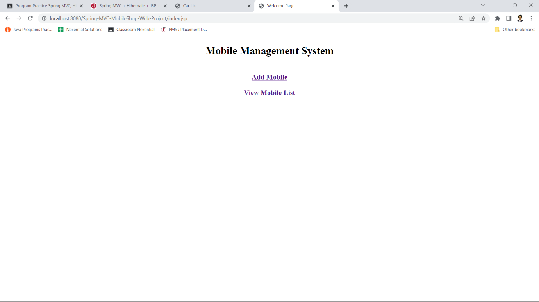

**Add**

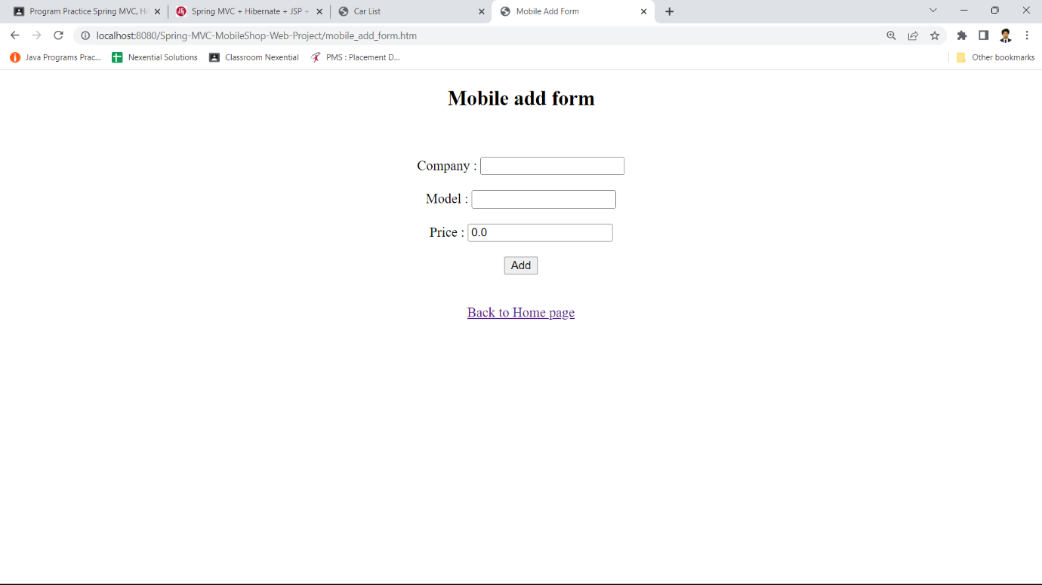

**Update**

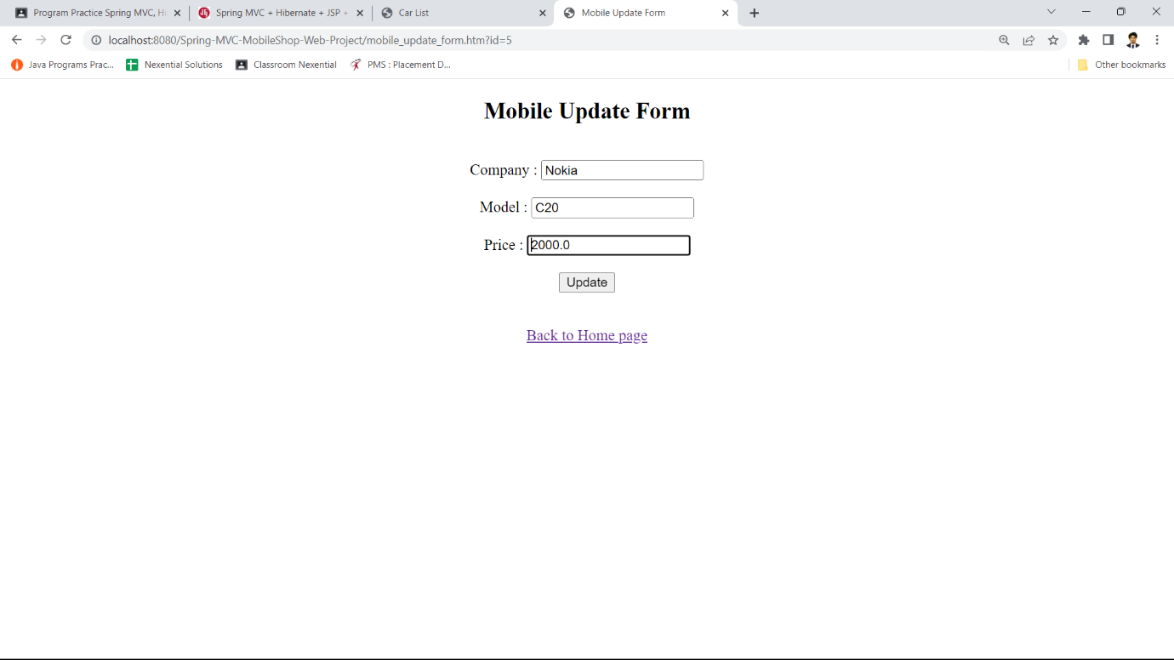

**Delete**

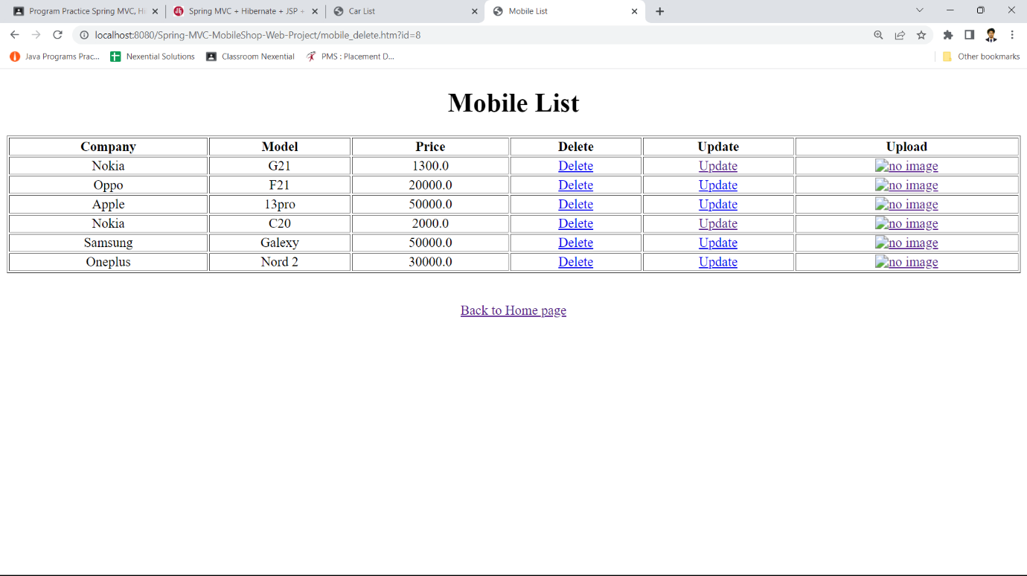

**Select All records**

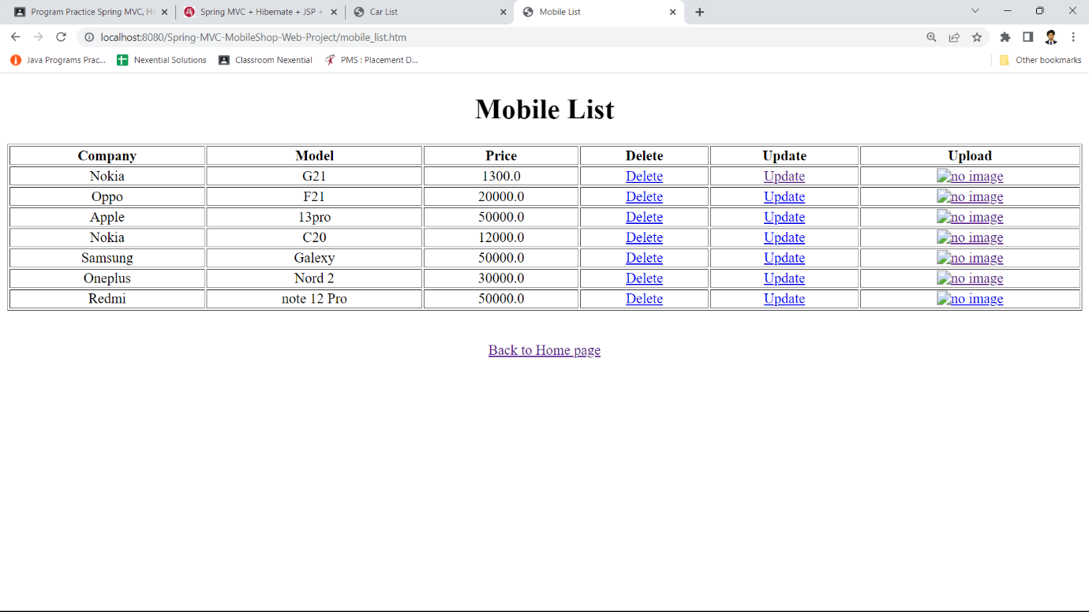

**Database table**

